|  |  |  |  |  |  |
| --- | --- | --- | --- | --- | --- |
| Date | 6-Dec-22 | | | Tester Name | Mayuri Patel |
| Environment | Penfax - Test | | | Login used |  |
| Operating System | Select OS | Version: | Update: | | |
| Software Used | Select Software | Version: | Update: | | |
| Select Software | Version: | Update: | | |
| Release version | 22.4.1 | | | | |
| Title |  | | | | |
| Test Type | Regression | | | | |
| Test Scenario | Set up monthly payments to pay Via cheque | | | | |
|  |  | | | | |
| Expected Results |  | | | | |
| Pass/Fail | Pass | | | JIRA# | N/A |

Describe your steps with screenshots:

Search for a member who does not have payment instruction set up via cheque and have current monthly scheduled withdrawal Instruction

Open that member profile

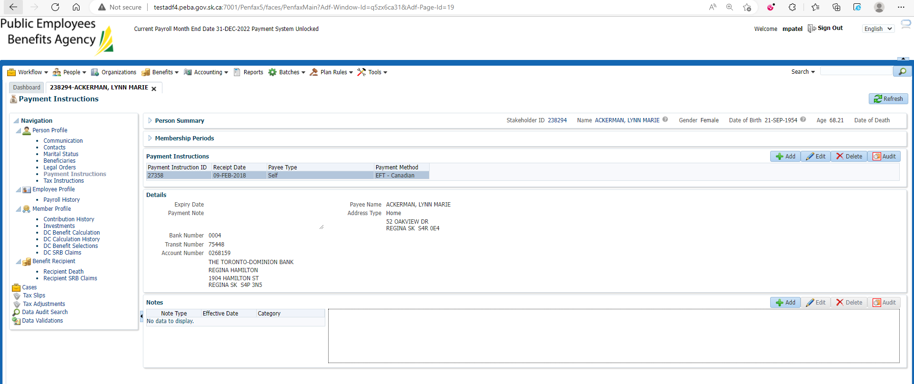

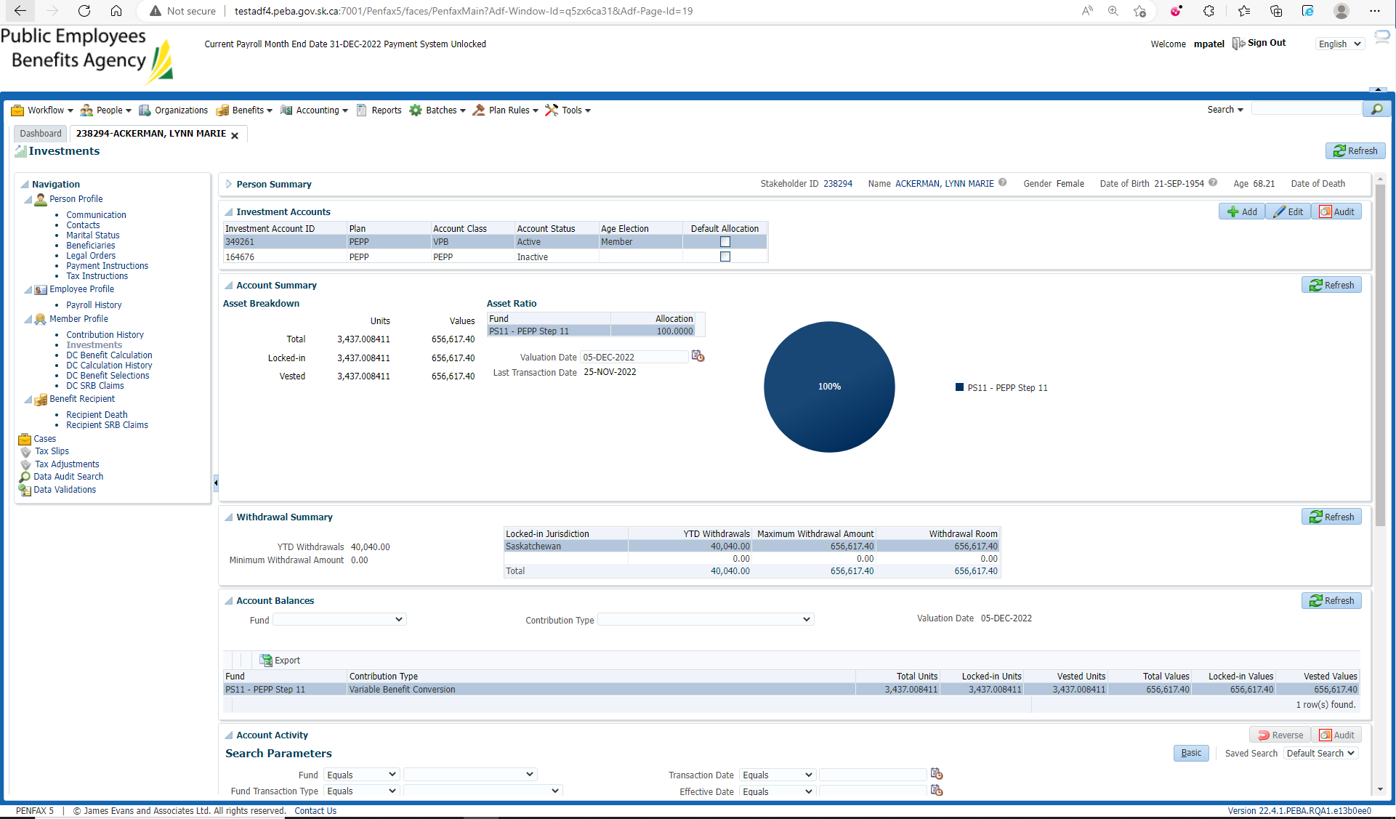

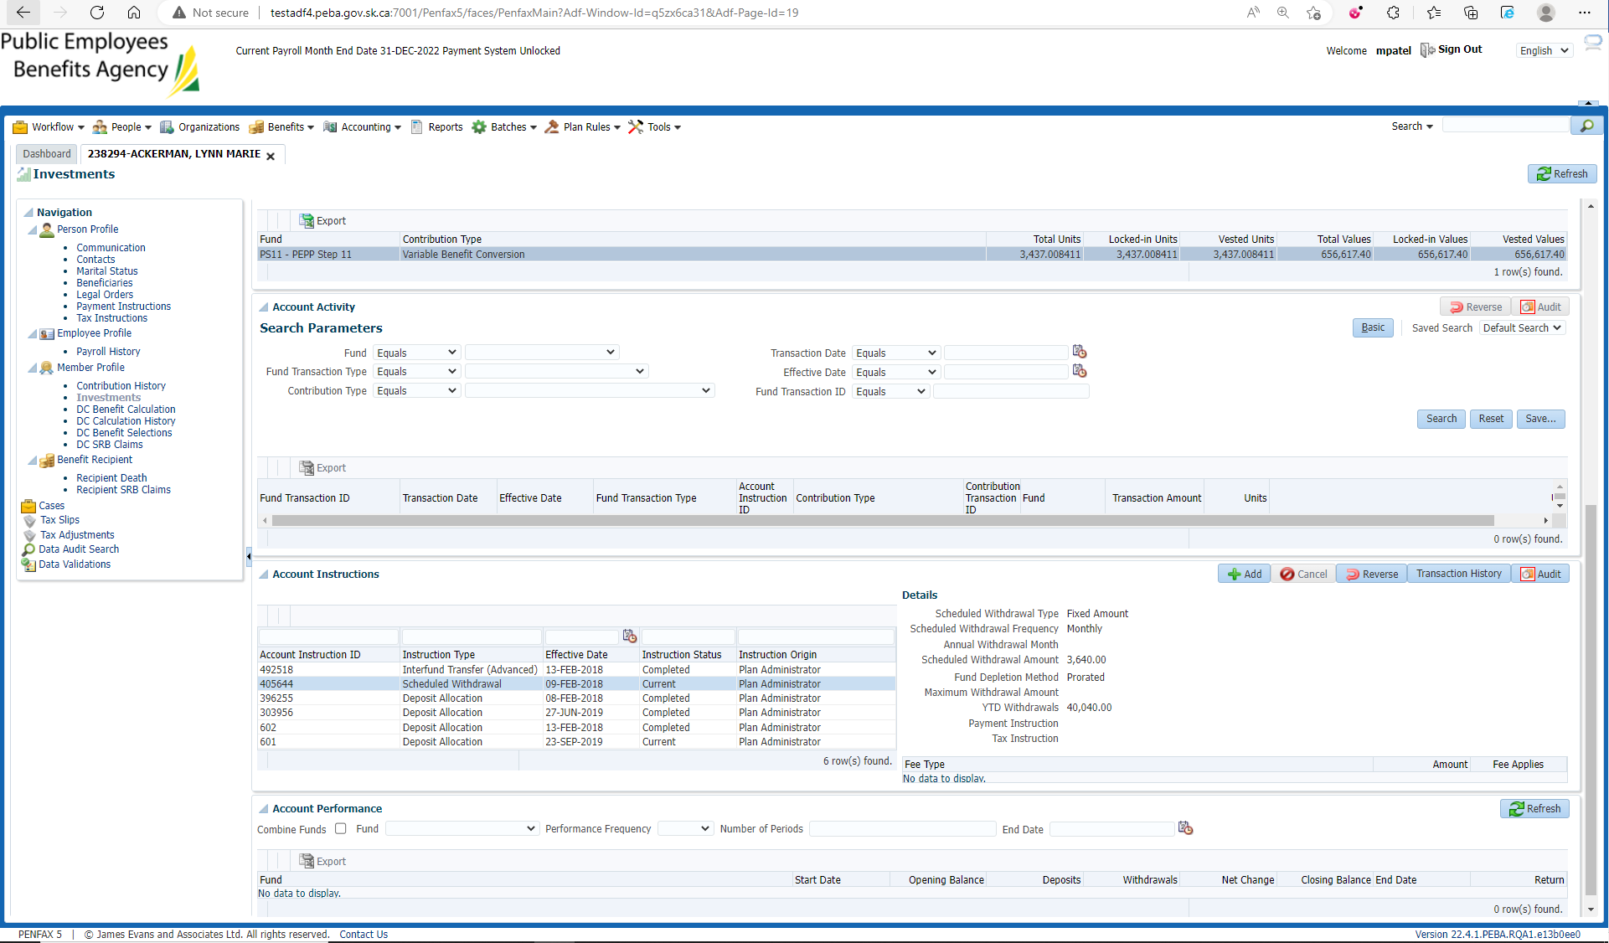

Go to Payment Instructions under Person profile

Add payment Instruction with payment method via cheque

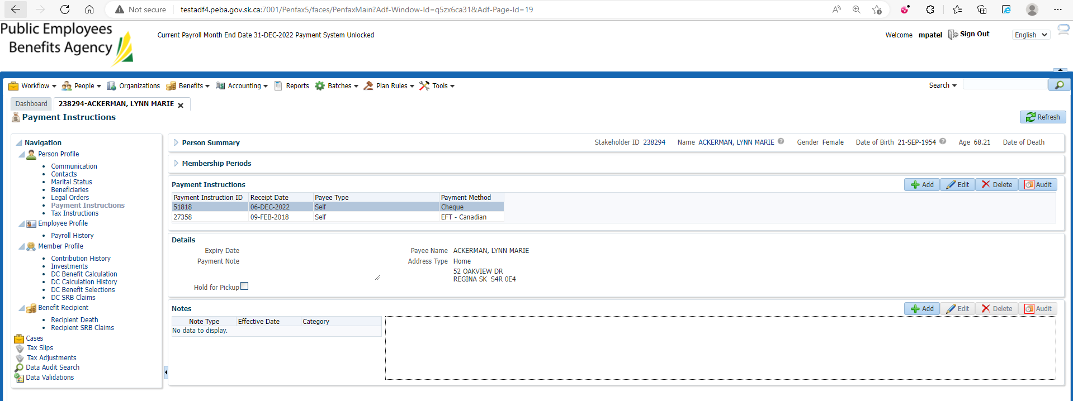

Benefit recipient🡪Income Benefit tab

Select PEPP Income Benefit

Under Payment instruction, add newly added payment instruction vis cheque and end previous payment Instruction by entering end date

Save

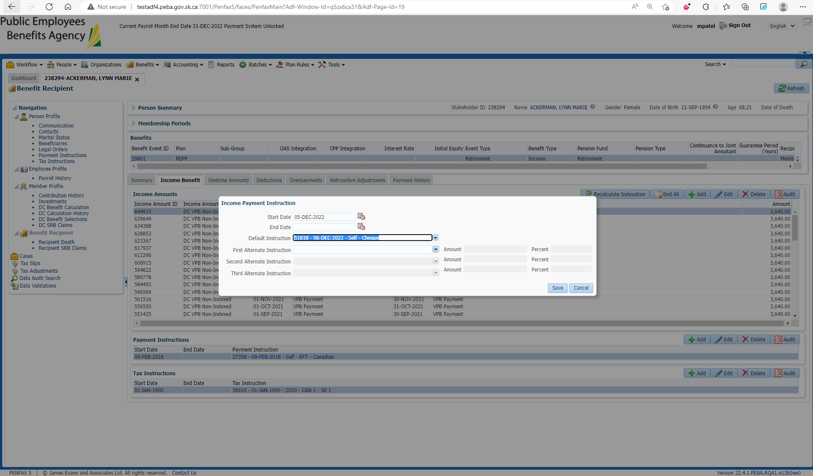

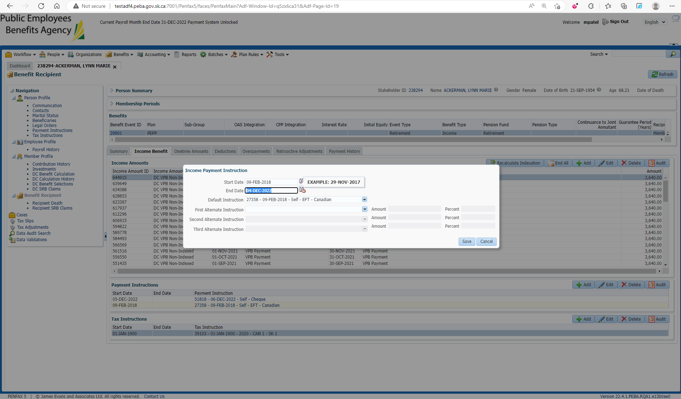

Changes are reflected

